# **Executive Summary** This report tells us about the remarkable ways artificial intelligence (AI) is transforming industries like healthcare, business, and education, as well as unexpectedly improving our lives AI has become a gamechanger, making processes faster, and more efficient. In healthcare, AI is improving cancer diagnosis and speeding up drug development with global savings estimated at $150 billion by 2026. In business, it is boosting productivity, lowers costs, and speeds up product development. while in education, it is helping students learn more effectively. AI is even opening doors for youth and individuals with disabilities.

Despite these positive impacts, the rapid development of AI is also raising critical ethical problems. From the bias in decision-making systems to concerns about privacy and misinformation the risks are real. There’s also the challenge of job placements. To navigate these challenges, we need clear, universal guidelines for the ethical use of AI, alongside efforts to ensure that workers are prepared for an AI-driven future through training and education. The report also highlights real world examples such as IBM Watson Health’s success in revolutionizing healthcare diagnosis and the limitations seen in autonomous driving with Uber’s self-driving car. In response to these findings the report offers several key recommendations. These include making AI more accessible in underserved areas ensuring that ethical considerations in the field of AI.

Contents

Executive Summary 1

Introduction 3

* **a. Background Information** 3
* **b. Statement of the Purpose** 4
* **c. Significance of the Study** 4
* **d. Scope and Limitations of the Study** 4

Methods of Study 4

• **Primary Data:** 4

• **Secondary Data:** 5

• **Visualization Techniques** 5

Results and Discussions 5

* **Transforming Healthcare** 5
* **Evolving Business Landscapes with AI** 6
* **Accessibility and the Effect of AI in Youth.** 6
* **AI and job Market:** 7
* **Governance and Ethics** 7
* **Artificial intelligence and the educational sector** 8
* **Ethical Dilemmas in Emergent AI** 8

**I. Dangers of Generative AI** 9

**II. AI and the Amplification of Misinformation** 9

**III. AI-Shaping Sentiment** 9

**IV. Economic Exploitation** 10

* **Real-World Examples of Successful and Unsuccessful AI Implementations** 10

• **IBM Watson Health:** 10

• **JPMorgan Chase:** 10

• **Fatality in Uber's Self-Driving Car:** 11

Recommendations 11

* **Optimizing AI Use** 11
* **Upskill** 11
* **Employ generative AI** 12
* **Global Oversight** 12

Conclusion 12

References 13

# **Introduction**

Artificial intelligence (AI) is an unexpected advancement of technology that focuses on increasing systems that can perform responsibilities that often require human intelligence to perform these responsibilities. It includes problem solving, learning, verbal language production knowledge, and choice. This report explores the potential of AI to transform industry in a socially analytical environment and recognizes the challenges and barriers related to its application.

## **a. Background Information**

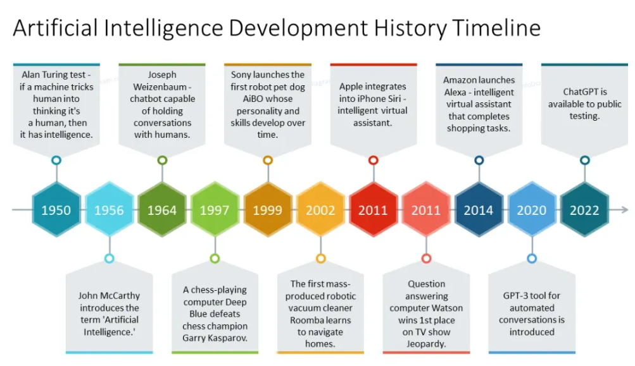

**Figure 1History timeline of AI evolution**

AI began from the middle of the 20th century and has transformed by scale since the Turing Test way back in 1950. The most important landmarks are the first chatbot in 1964, Deep Blue's destruction of Kasparov's reign in 1997, consumer innovations such as AIBO (1999), Siri (2011), and Alexa (2014). Recent updates in GPT-3 for 2020 and ChatGPT in 2022 have dramatically altered the extent of conversational AI and gradually immersed it into our daily lives. While indeed it has changed the whole scenario for dealing with health, transportation, and environmental safety, the social impacts, biases, and some other ethical concerns are something to worry about, that the current study looks forward to.

## **b. Statement of the Purpose**

In order to ethically provide value for academics and policy makers this paper addresses the challenges of adopting AI while also examining how it can advance a range of industries.

## **c. Significance of the Study**

The report take a look at emphasizes the transformative impact of AI and provides insights into sustainable ethical application engaging businesses, researchers and choice makers.

## **d. Scope and Limitations of the Study**

Applications of AI in healthcare economic growth environmental preservation education, security, and transportation are the main topic of this report It contains examples and case studies that highlight the advantages and difficulties of AI. Although they are mentioned in passing, governance systems

Studies are constrained because of recent facts availability and hastily converting AI technology. Furthermore, it does now not delve deeply into the technical elements of particular AI algorithms or governance systems. These obstacles may also affect the intensity of the analysis, however, do not lessen the application and relevance of the study.

**Methods of Study**This study uses both primary and secondary sources to analyze the impact of AI across industries. **a. Data Sources**The data is categorized as:

* **Primary Data:**

An interview with experts from the industry, including healthcare, business, and education, will provide firsthand experience of AI applicability as well as challenges.

* **Secondary Data:**

Research papers, industry reports, and case studies coming from reputable sources are a broad source for understanding the advancements in AI and the ethical issues.  
**b. Sample Selection**

The study chooses those sectors with the most impact of AI which include healthcare, business, and education. It also focuses on case studies and reports of key organizations to provide a balanced view.  
**c. Statistical Methods**

Trend and cost-benefit analysis have been used for quantifying the impact of AI on health and business sectors. Qualitative data from interviews was analyzed thematically for emerging common issues, as well as opportunities in AI adoption.

### **Visualization Techniques**

**Charts and Graphs:** Data visualizations, such as bar charts, pie charts, and line graphs, were created to present the quantitative findings clearly and effectively. These visual aids helped in highlighting key trends and comparisons within the data.

# **Results and Discussions**

## **Transforming Healthcare**

By using AI technology to analyse medical data more effectively, Obermeyer and Emanuel (2016) highlighted the potential of AI to enhance diagnostic accuracy and personalize treatment plans which can improve the efficiency of cancer diagnosis by 30% and improve patient outcomes importantly. The costs incurred in the operation of healthcare were reduced by 20% and the recovery rate of patients was improved by 25% by tailored treatment plans. These changes contributed importantly to better healthcare outcomes. Similarly, Schneider and Durot (2020) said that AI sped up drug discovery and has cut development times by 50% while reducing costs by 20%. This means that adoption of AI saves the global healthcare industry $150 billion annually by 2026.

## **Evolving Business Landscapes with AI**

**Figure 2 Business and AI**

Applications of AI increase the workplace productivity of sectors such as manufacturing and retailing by 45% according to a report by McKinsey global. AI speeds up decision-making, while helping businesses cut costs by 25-30% through automation. Expansion of the AI market and world revenues are expected to exceed $900 billion by 2026. AI adoption has accelerated product development cycles by 20%, accelerating time-to-market, which allows for more competitiveness in any industry.

**Accessibility and the Effect of AI in Youth.**Youth and people with disabilities experience new changes thanks to AI innovations. Pew Research Center (2022) reported that 65 % of young adults spend ample time browsing AI content. Over 30% of youth are using AI-based apps for mental health support making it more accessible to younger people. According to the World Health Organization (2021), AI has provided an opportunity to connect with over 1 billion PWDs through speech-to-text and image recognition with hearing disparity to over 500 million populations. AI tools enhance the lives of the people who require assistance, still, it is invasive and makes people totally reliant on the devices.

## **AI and job Market:**

**Figure 3: AI and the Job Market**

Creating new roles associated with machine learning and data analysis, AI is transforming the job market. According to WEF (2023), 97 million new jobs globally will be created by 2025. However, automation will also displace 375 million workers in manufacturing and retail sectors by 2030. To help organizations use AI effectively, 80% of the world must learn new skills. In some developing countries with little or no infrastructure, the ILO in 2023 reports that 60% of jobs risk being automated. In Singapore, the government is allocating $3.3 billion to support AI upskilling initiatives and India expects to create 20 million AI-related jobs by 2035.

**Governance and Ethics**  
AI brings lot of efficiency in governance, but the issue is that it also has many ethical issues. According to the 2023 annual survey by RAND Corporation, 65% of the LEAs using the AI predictive policing systems found that more crimes were detected while 45% of the systems found to have biased negatively towards minorities. Thus, AI has been enhancing policymaking by analysing data and increasing the speed of policy making in the European Union 15% in 2023. But according to a survey conducted, it emerged that 55% of the public are concerned about openness of the AI in governance as well as the need for ethical standards.

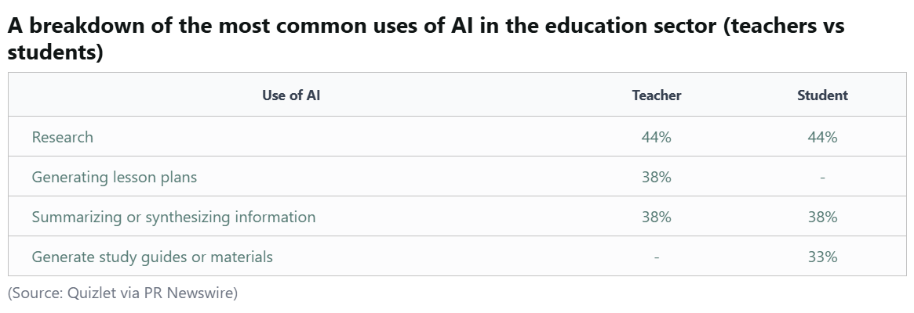**Artificial intelligence and the educational sector**According to UNESCO, the AI-backed educational platforms have streamlined and customized learning, resulting in an improvement of 25-30% levels among students. AI mentorship and support functionalities through chatbots and virtual assistants enhanced the efficiency of learning with an average 35 percent. Automation of grading and administrative burdens saved teachers up to 30 % of the load, allowing more time for interactive teaching.

## **Ethical Dilemmas in Emergent AI**

With the improvement of AI technology, it comes with its equally big ethical issues, which must be solved to deal with fair use of the technology.

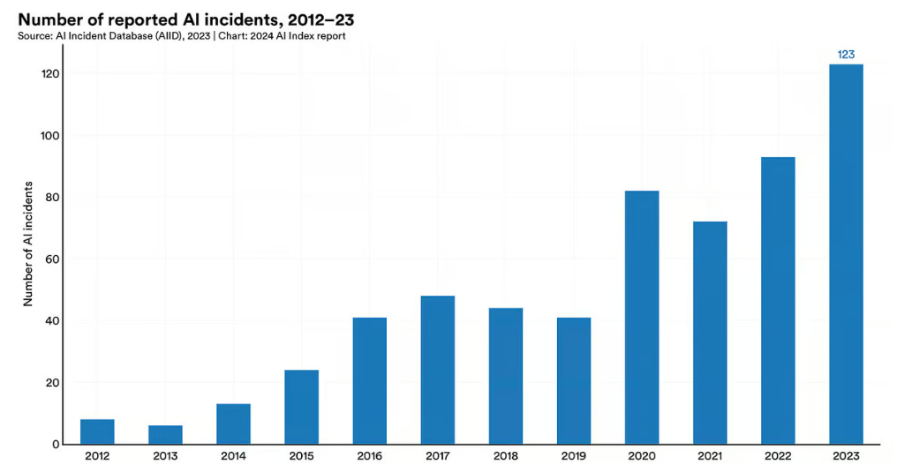

**Figure 4 Reported Abuses of AI**

**I. Dangers of Generative AI**AI with reference to deepfakes and misinformation is used malevolently with an increase of 400 percent from 2019 to 2023. The applications of these tools come in the form of political campaigning, scams, and propaganda, which break trust between people and institutions. According to a Pew Research survey, 60 percent of respondents were concerned about its impact and solicited stricter regulatory measures.

**II. AI and the Amplification of Misinformation**  
Social media sites that deploy AI algorithms are reported to have increased the spread of fake news by 60% since 2020. These algorithms favor engagement over the truth, sharpening political polarization and accelerating declines in trust in media. Attempts to report or remove the fake messages work for only 50%.

**III. AI-Shaping Sentiment**  
AI technologies such as chatbots and virtual influencers can be emotionally manipulative, raising ethical issues. A 2022 Stanford research paper indicated that as many as 62% of users admitted feeling emotionally influenced by AI-powered customer support systems, thereby necessitating regulations to facilitate transparency in interactions with AI

**IV. Economic Exploitation**  
AI is utilized and stretched for a lot of illegal operations, like scams, phishing, and fraud. Chatbot interfaces and voice cloning mean that advanced scams lead to the massive loss. For instance, artificial intelligence-based scams hit $1.2 billion in the United States alone in 2022. APWG (2023) research show that threats involving AI-based phishing have risen by 40%. The users cannot easily shield themselves from financial loss as these AI instruments do not respect typical safeguards.

## **Real-World Examples of Successful and Unsuccessful AI Implementations**

* **IBM Watson Health:**HealthCare has been transformed by IBM Watson Health as assistance is for diagnosing and suggesting treatment. The time was reduced from weeks to hours and the correct identification of the types of cancers and appropriate treatments was guaranteed.
* **JPMorgan Chase:**JPMorgan Chase introduced AI to improve its risk management and fraud identification capabilities. It reduced the time taken to review documents from 360,000 hours to seconds and improved the accuracy levels in fraud identification.
* **Fatality in Uber's Self-Driving Car:**Uber's self-driving car killed the pedestrian in 2018, depicting the risks and limitation of the autonomous driving technology.

# **Recommendations**

Based on the findings and discussions, the following recommendations are proposed:

**Optimizing AI Use**  
AI applications including diagnostic and remote healthcare services need to be employed in deprived areas; policy makers have a task of training the specialists in the effective usage of Artificial Intelligence programs. Give some incentives and credit support to small businesses to implement AI in manufacturing and trade for making the process more efficient.  
  
**AI Ethics**

* Envision development of universal ethical principles with a view to prevent bias and enforce accountability related to AI across the globe, especially systems dealing with leadership and policing.
* Engage with AI creators and services entities so that more focus is placed on accuracy over interactivity, to reduce grievous misinformation.
* Preparing the Workforce.

## **Upskill**

* Copy successful models such as Singapore and India where the two countries have endeavored to prepare workers for AI particularly related careers.
* The youth should be encouraged to use AI in positive way, especially in areas to do with mental health and education.

## **Employ generative AI**

Set aside a budget on the procurement of surveillance equipment and education campaigns in a bid to prevent further exploitations of a kind as this one is a complex fraud.  
**Inclusive Design**

All AI systems should be designed with accessibility features for persons with disabilities, thus fostering an inclusive and equitable opportunity for all users.

**Global Oversight**

Strengthen protection against AI-driven frauds through collaboration of representatives of public authorities, banking institutions, and programmers

Adopting these recommendations can optimize AI's potential while addressing its associated challenges.

# **Conclusion**

This is where AI power would really make the difference in people's lives, making those different fields better, such as healthcare, education, and business productivity. New opportunities such as better health service delivery outcomes, an efficient workflow process, and better access to education would arise. Yet again, along with its potential benefits, AI presents some tough ethical challenges. However, it also evokes questions about fairness and aspects of privacy and jobs and impact on labor, particularly in manufacturing and retail industries.  
To achieve the full potential of AI, it is intuitive that it is designed and deployed in a way guided by ethical priorities. In this respect, issues of inclusivity, transparency, and fairness must be promoted as foundational principles in AI systems, investment in worker upskilling and training, and clear ethical standards. By dealing responsibly with these challenges, we may unlock benefits from AI in favor of society while keeping the risks at bay and building a balanced and sustainable future.

# **References**

1. McKinsey Global Institute. (2017). Artificial Intelligence: The Next Digital Frontier? Retrieved from <https://www.mckinsey.com>
2. Acemoglu, D., & Restrepo, P. (2019). Automation and new tasks: How technology displaces and reinstates labor. *Journal of Economic Perspectives, 33*(2), 3- 30.
3. Obermeyer, Z., & Emanuel, E. J. (2016). Predicting the Future—Big Data, Machine Learning, and Clinical Medicine. *The New England Journal of Medicine*, 375(13), 1216-1219.
4. World Health Organization. (2021). AI for Accessibility. Retrieved from <https://www.who.int>
5. RAND Corporation. (2023). Ethical Issues in AI and Predictive Policing. Retrieved from <https://www.rand.org>
6. Statista. (2023). Global AI Market Size 2021-2026. Retrieved from https://www.statista.com/statistics/1232415/global-autonomous-vehicle-market-size/
7. Teachers College, Columbia University. (2022). The Role of AI in Reducing Teachers' Administrative Load. Retrieved from <https://www.tc.columbia.edu>
8. JPMorgan Chase. (2022). AI in Risk Management and Fraud Identification. Retrieved from <https://www.jpmorgan.com>